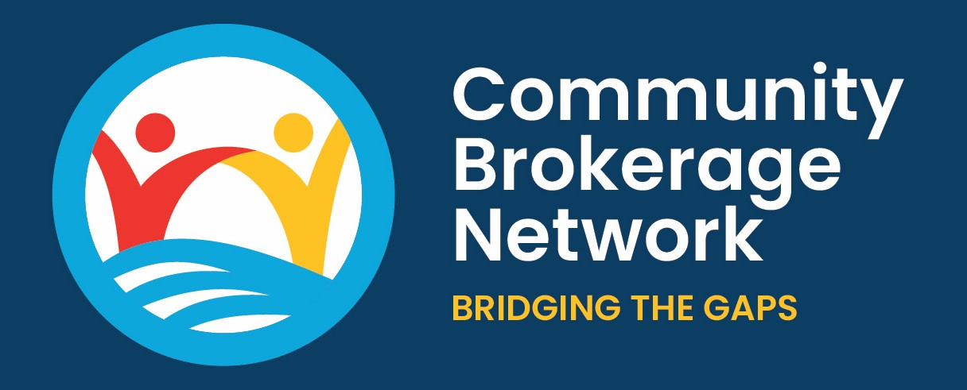 Customer Complaints Policy

At CBN, we care deeply about the people we support. We aim to provide a helpful, friendly, and professional service at all times. But we know things don’t always go as expected. If something hasn’t gone quite right, we want to hear about it, so we can put it right and learn for the future.

What’s this policy for?
This policy explains how you can raise a concern or complaint if you're unhappy with the service you've received from us. It also outlines what you can expect from us if you do.

What can you complain about?
You can use this policy to complain about things like:
- A delay or lack of response from us
- How you were treated by a member of the team
- Feeling that we didn’t follow through on something we said we would do
- A disagreement about what we can or can’t offer you
- Any aspect of our service that didn’t meet your expectations
If your complaint is about another organisation (like social work, the NHS, or a care provider), we’ll help you understand how to raise it with them, but we can’t investigate on their behalf.

How to complain

Stage 1 – Informal resolution
Where possible, we’ll try to resolve things quickly and informally. Just speak to your broker or email us at info@communitybrokeragenetwork.co.uk. You can also call us on 07769 698 606.
A senior member of staff will look into your concern and aim to provide a full response within 5 working days.

Stage 2 – Formal complaint
If you're not satisfied with the outcome at Stage 1, you can ask for your complaint to be reviewed. This will be handled by the Chair of the CBN Board, who will carry out a more detailed investigation.
You’ll receive a written response within 20 working days of us receiving your formal complaint.

What we’ll do
We’ll:
- Listen to what you have to say
- Take your concerns seriously
- Investigate what happened
- Let you know what we find and what action (if any) we’ll take
We won’t accept any abuse or discrimination, and we ask that all complaints are made respectfully.

If you’re still not satisfied
CBN is a small organisation and does not fall under the Scottish Public Services Ombudsman (SPSO). If you need further help, we can signpost you to an independent advocacy organisation who may be able to support you with your concerns.

We value your feedback
Complaints help us learn and improve. We also welcome compliments and suggestions, so please don’t hesitate to get in touch.

